**Advising (Student and Advisor) webpage**

Overall Challenges:

One of the main challenges that we had in making this project was with understanding each other’s coding styles. We both had very different coding styles so it was a trip in itself in figuring out how we both were coding whenever we needed to help each other out with some features.

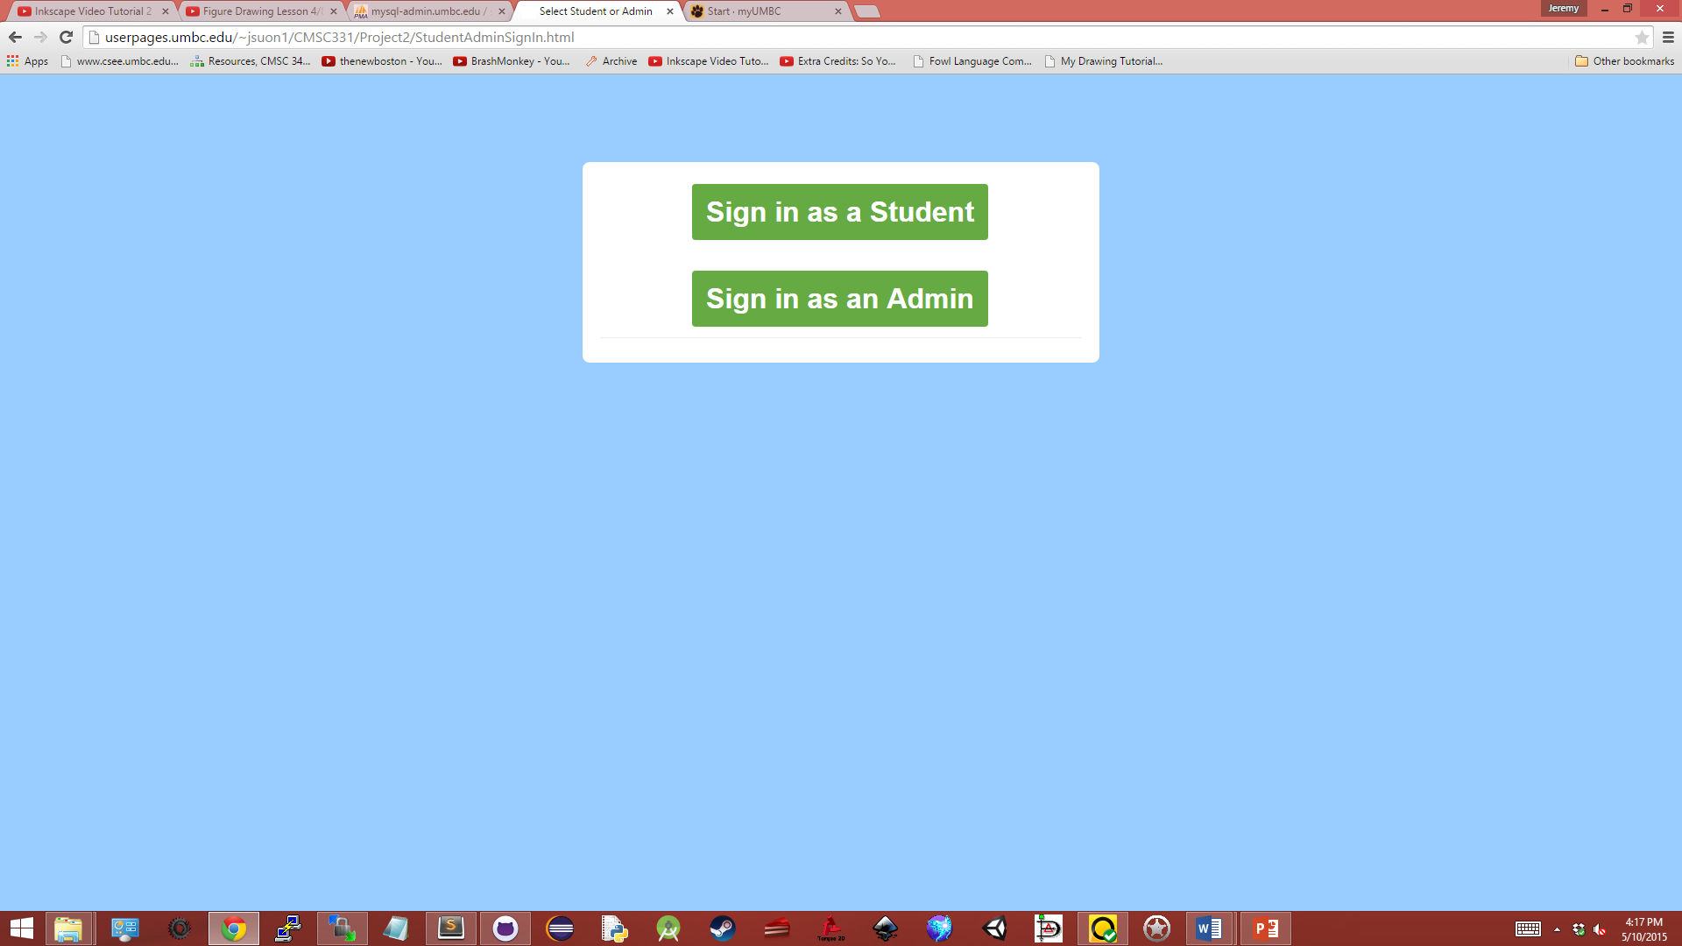

When starting up the webpage, you start at a sign in page where you can select whether to sign in as a student or an advisor.

 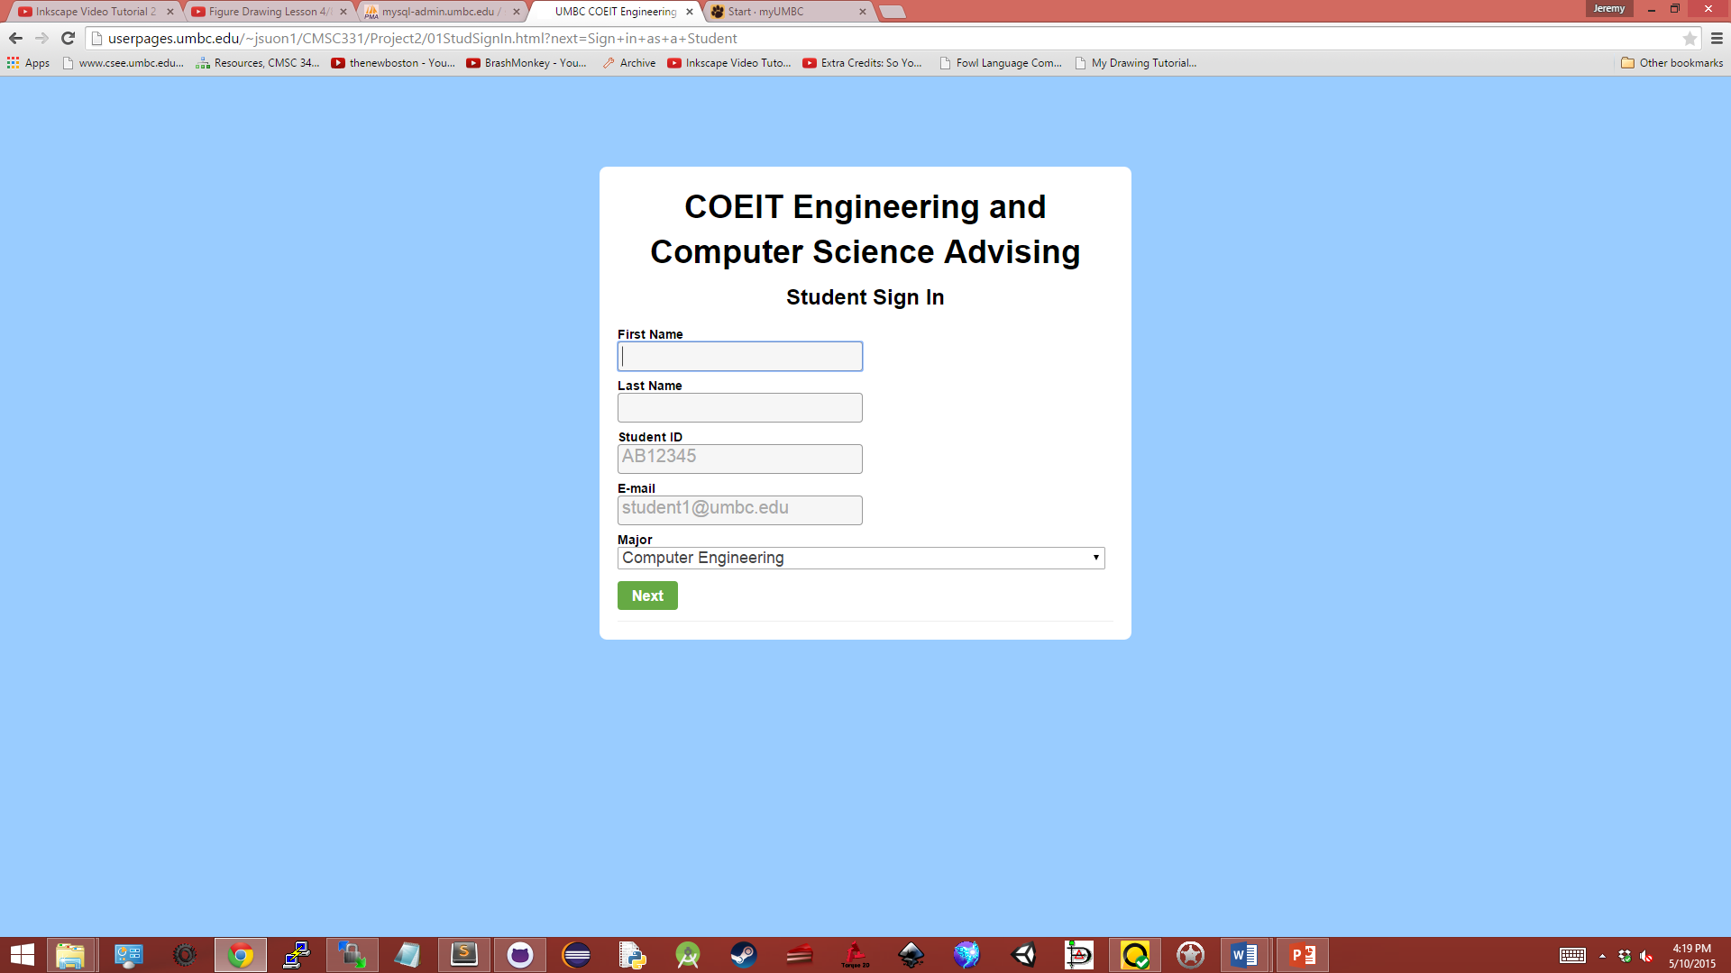

After selecting which you would like to sign in as, depending on your choice, you will be prompted for different information. On the admin side, you will be prompted for a username and a password. The admin side works with a verification program so a correct username and password combination is needed. Otherwise, you would be redirected to the same page with an error message indicating an incorrect combination. On the student side, you will prompted for your first name, last name, student ID, email, and major. The student is required to enter in all of the information, taking careful note for filling in a matching pattern for student ID and email, before they are able to proceed.

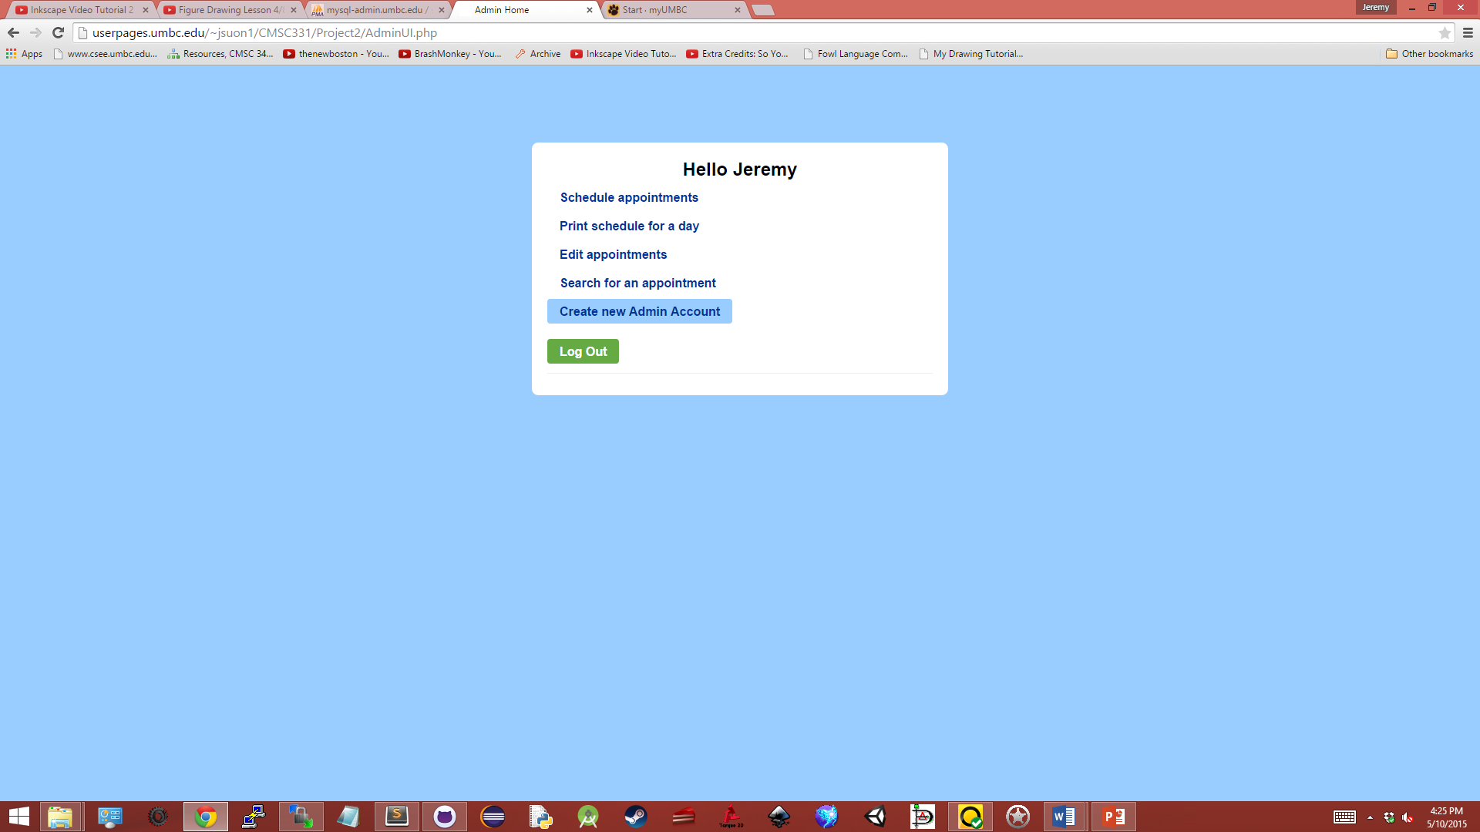 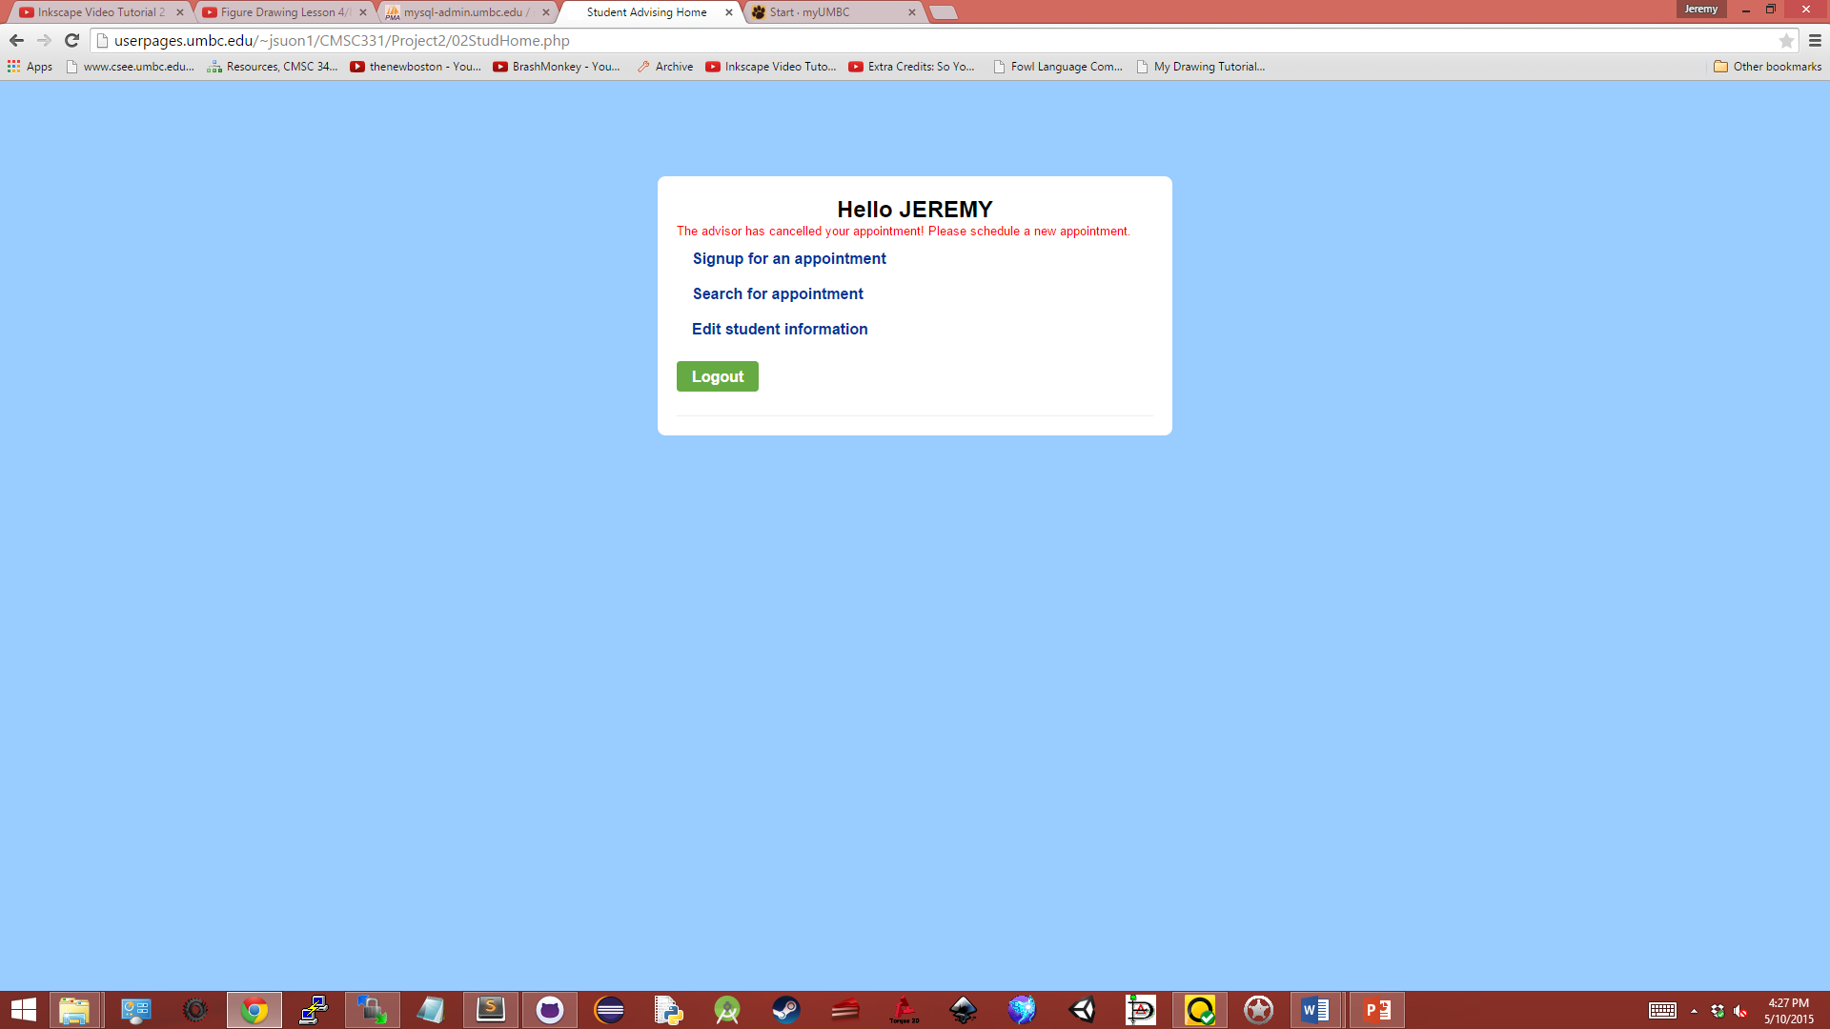

Following the sign-in page for the advisor and student side, the user would then be led to the user interfaces for their corresponding side. For the advisor side, advisors can choose out of the options given to either schedule appointments, print their schedule for a day, edit appointments, search for an appointment, or create a new advising account. For the student side, options will vary depending on whether or not the student has an active appointment scheduled or not. From the options shown, for a student that has not yet made an appointment or a student that has either cancelled, or has had their appointment cancelled by an admin, the student is able to either signup for an appointment, search for appointments, or edit their student information present in the database.

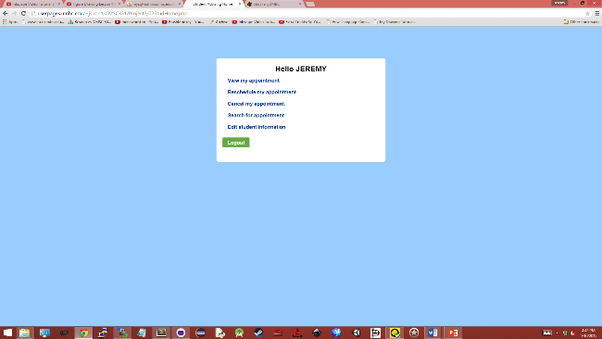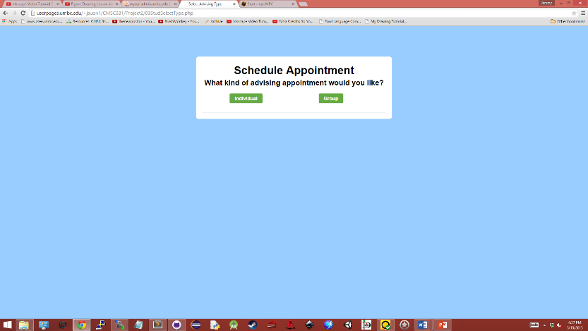Among the options, when an advisor selects to schedule appointments or edit appointments, or when a student decides to sign up for an appointment, they are both directed to a variation of this page, shown on the left. Here, advisors or students would then follow to select whether they want to schedule/edit/sign-up for individual appointments, or group appointments.

Following on the student side, after a student has managed to schedule for an appointment, they then have the options to either view the appointment they’re scheduled for, reschedule their appointment and cancel their appointment in addition to the options they had previously.

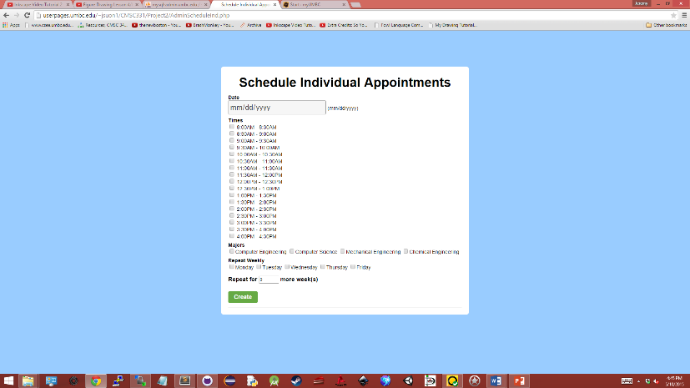Now following from the advisor side, after selecting to choose either to schedule for individual appointments or group appointments, advisors would be further prompted for information about the appointment. Variations of a page such as this can be seen on the many functions available to either the advisor or student side. For the advisor side, when rescheduling, searching, or editing appointments, the advisor would have to select options such as date, time, major, days that may have repeated schedules, or number of weeks to repeat a certain schedule. For the student side, when selecting to schedule or reschedule, students will be taken through a series of options to select an advisor or an appointment date and time. Both would then be lead to a results page consisting of the results retrieved from the information gathered for the selected process. For scheduling and editing appointments, advisors would be led to a confirmation page to inform them that appointments have been created, edited, or deleted and then displays the information of the appointment and results. If the advisor had canceled an appointment in which a student is enrolled in, a message will display stating that the student has been notified of this cancellation through email.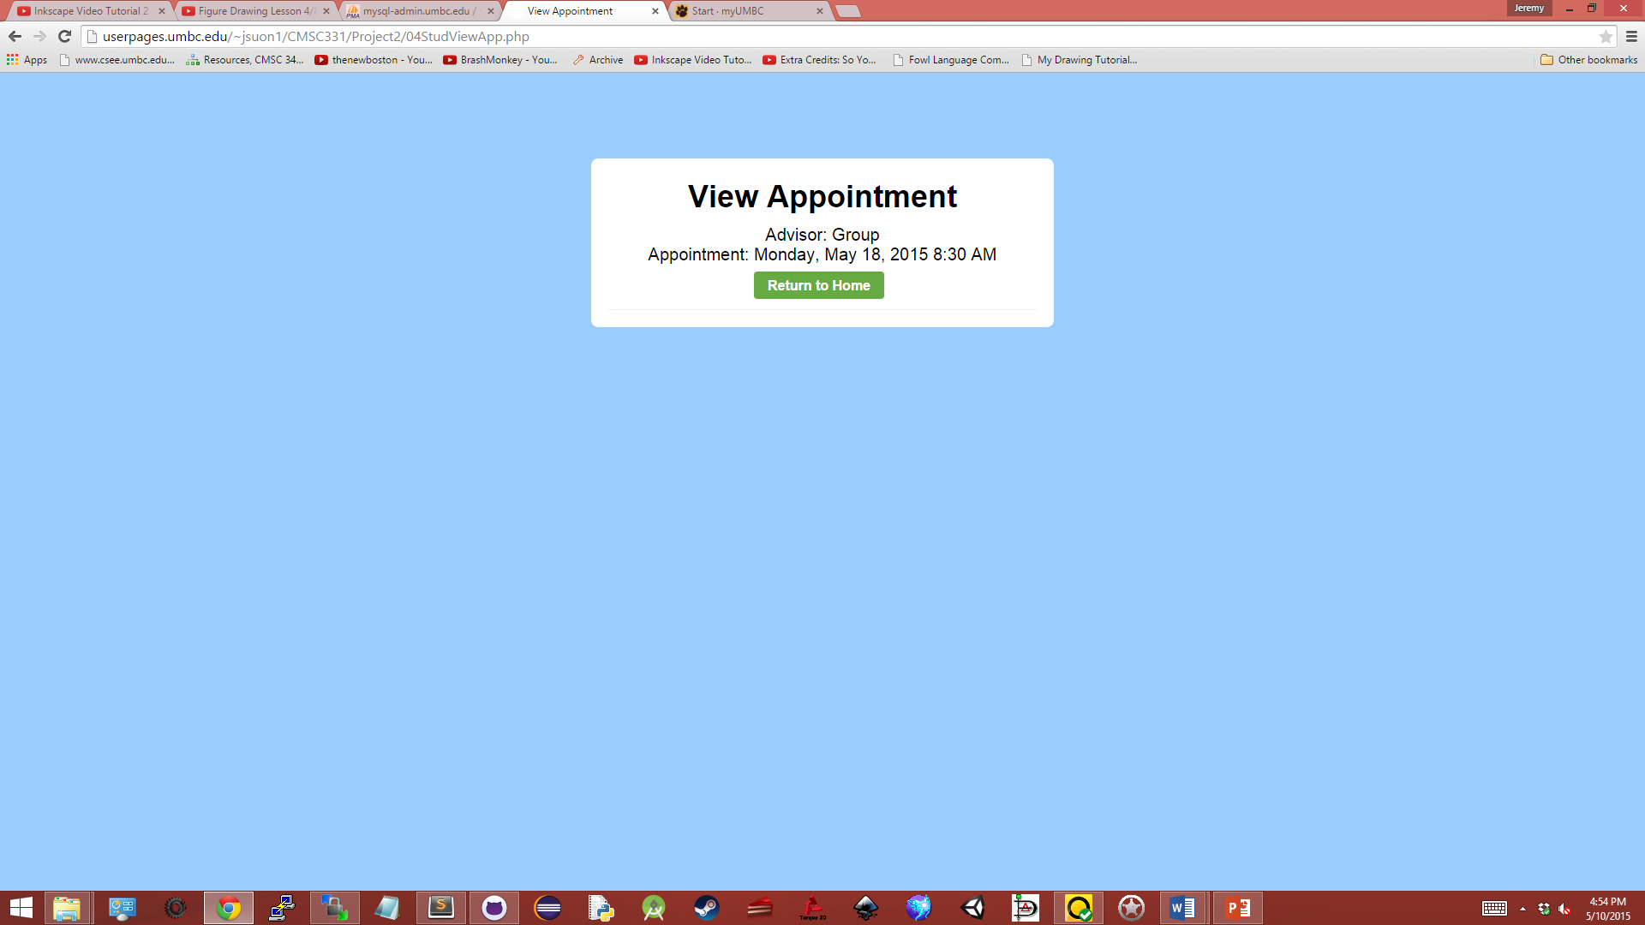 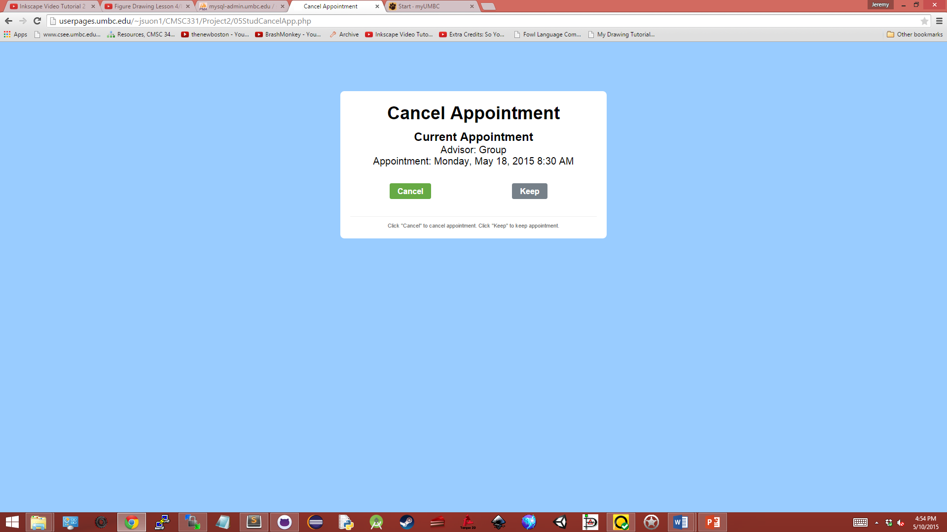

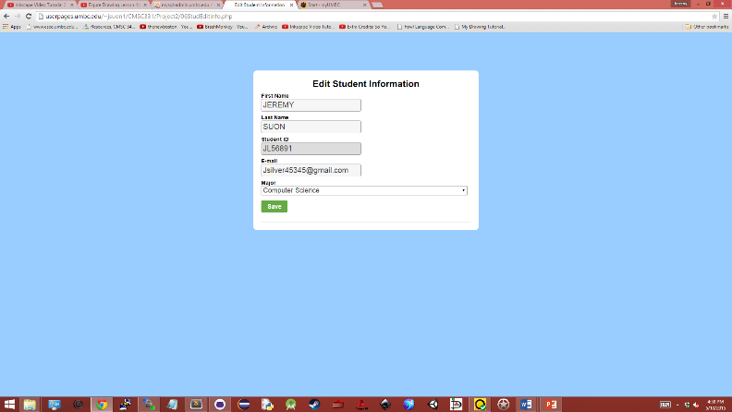Among the student options available, after scheduling an appointment, students have the option to view and/or cancel their appointment. The pages shown above are the resulting pages shown when these options are chosen. For viewing an appointment, the student is led to a page that displays the information of their current appointment that they are scheduled for followed by a ‘return home’ button. Where as for cancelling an appointment, the student is led to a page displaying the information of their current appointment, and then the option to either cancel that appointment or keep that appointment. Upon their selection, the student would then be led to a confirmation page informing them that their appointment has been successfully cancelled or remained unchanged with a return home button.

Additionally, students can edit their information that is present within the database, and upon doing so, they are able to change all information on themselves, with the exception for their student ID which cannot be changed.

 

From the advisor side, advisors have the option to print their schedule for a day. Upon doing as such, they are prompted for a date and whether they would like to view individual appointments, group appointments, or both. Afterwards, they are led to a results page which displays the information that they have requested. If there are no appointments to be shown, the page would simply list that there were no results found.

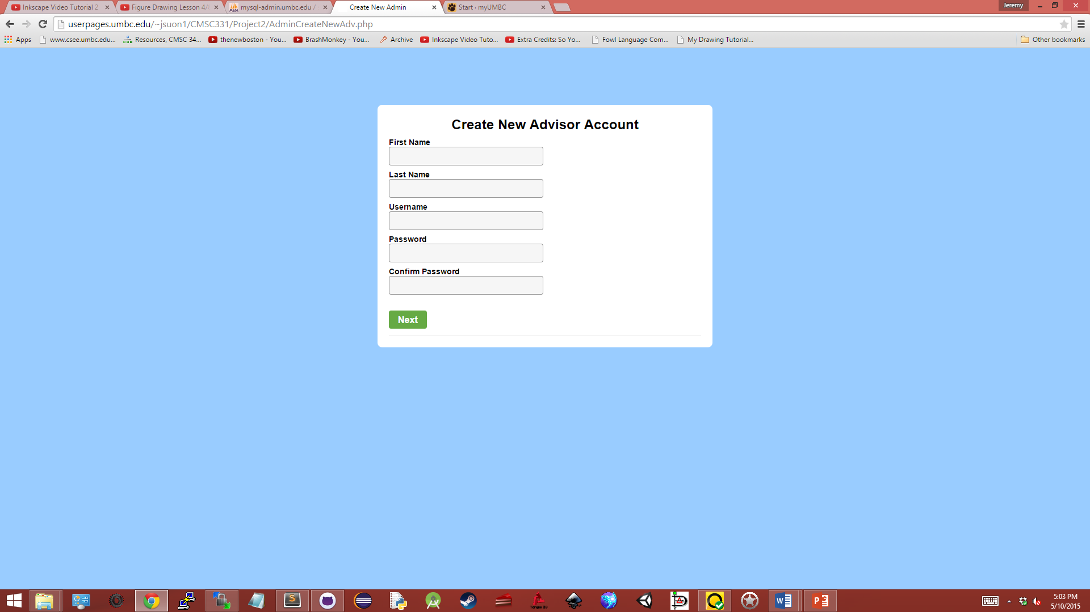 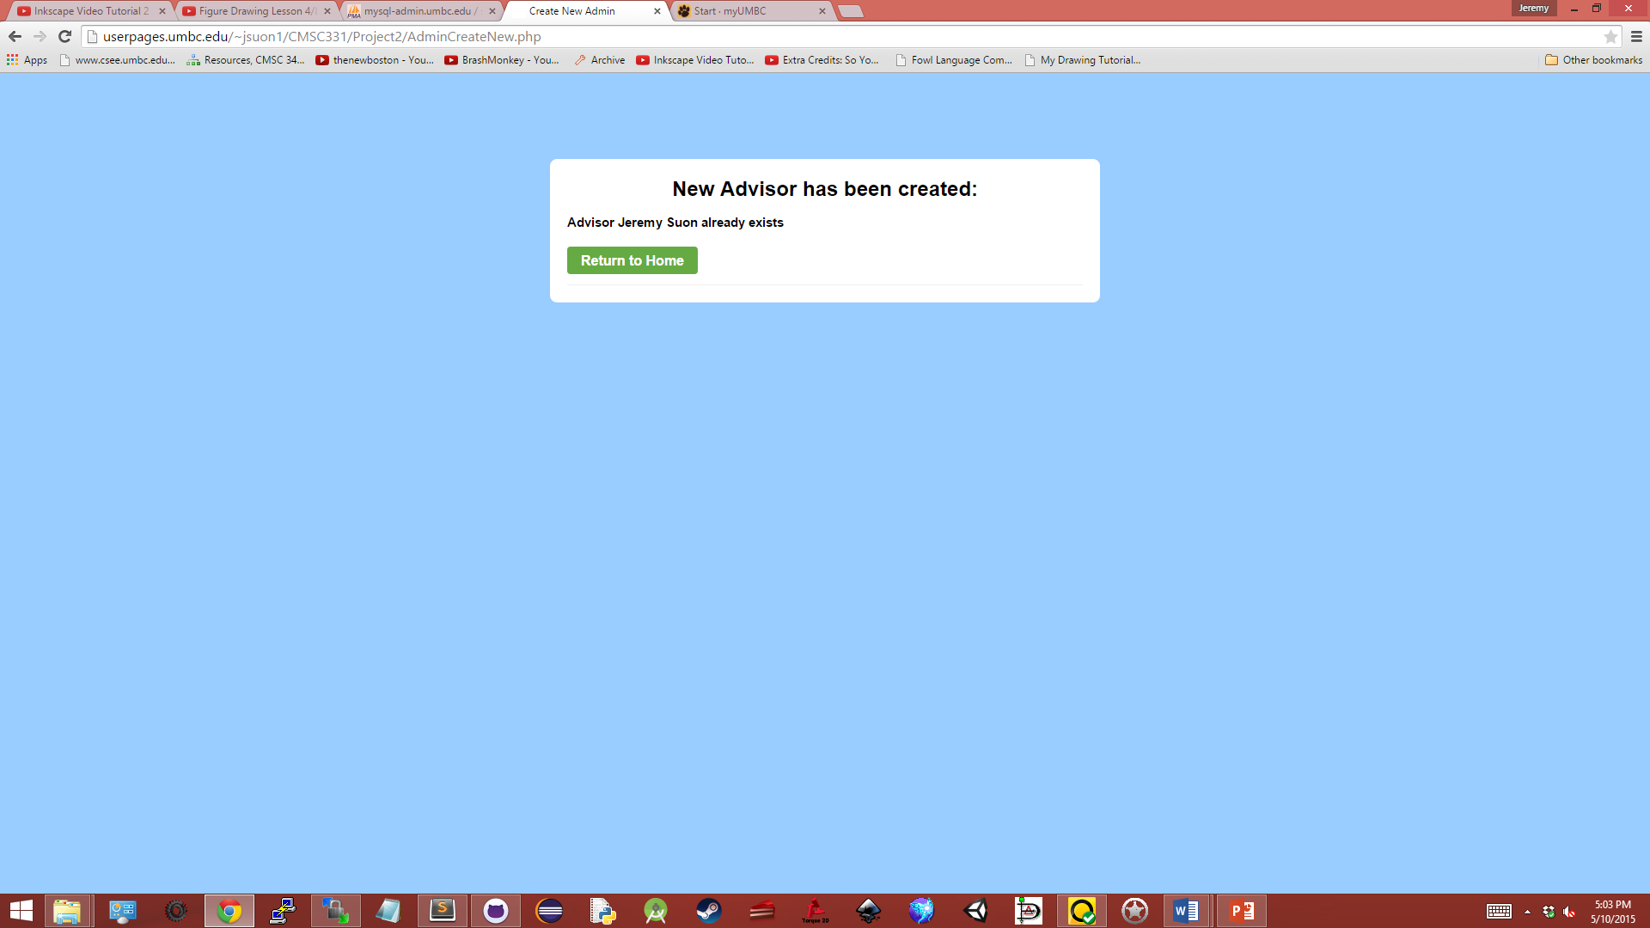

Finally, the last option for advisors is the choice to create a new advisor account. This function was implemented in order to allow advisors to be added in the event that new advisors are employed. Upon selecting this function, advisors would be led to a page where the new advisor would be able to enter in their information, that is, their first name, last name, username, password, and a password confirmation. They will then be led to a confirmation page stating either that the new advisor account has been created, or that it already exists. In the event that the password and password confirmation fields do not match, users would be redirected to the new advisor creation page with a message saying thus; this functions similar to the verfication feature for the advisor log-in page.